
Submitted by : Spogmai jan
Roll no : 2430 - 0081
Course : ai lab
Date of submission : 12/03/2026
Department : computer science
Submitted to : mam wardah

Assignment n0 :05
Task :
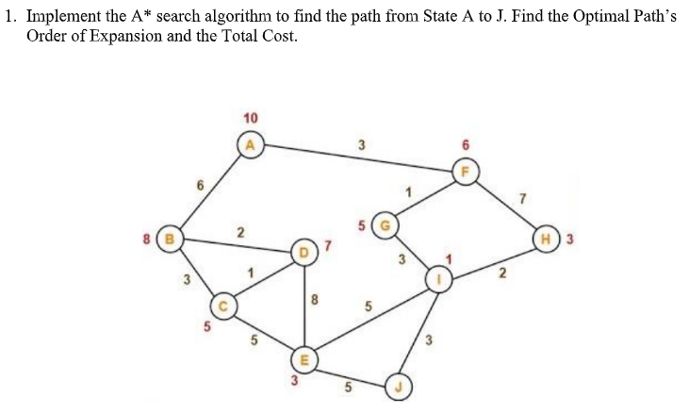
Code:
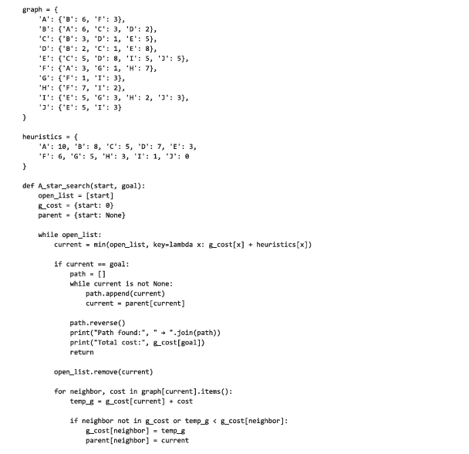

Output:



